**THE USE OF THE NOUN GROUP IN ENGLISH.**

**1) The essential parts of a noun group**

Unless a noun is used in a generalizing sense (see articles), a noun group consists or at least the following elements: a determiner and a noun.

**Determiner:** an **article** (*the, a, an, some, any*), a **quantifier** (*no, few, a few, many,*etc.), a **possessive** (*my, your, whose, the man's,* etc.), a **demonstrative** (*this, that, these, those*), a **numeral** (*one, two, three* etc.) or a **question word** (*which, whose, how many, etc).*

OBS: in some very rare cases, a noun can only be preceded by ONE determiner.

   **Examples**:the man, some women, a few dogs, your horse, the man's horse* , that car, whose money; how many bottles? (In this example, **the man's horse\*** there *appear* to be two determiners before **horse**, but in fact there is only one: the determiner before **horse** is **the man**, and the article the is the determiner of the word **man**.)

**2) Other parts of a noun group**

A noun group can also contain one or more modifiers: a modifierI is an adjective,an adjectival phrase, a secondary noun, a prepositional phrase or a relative clause.  
The principal noun in a noun group is called the **head noun**.

* Adjectives are placed before the head noun: as inthe Great Gatsby  
  Adjective phrases usually come before the head noun:  as in: a black-and-white striped vest; a rather tight-fitting dress
* Secondary nouns behave exactly like adjectives, and  come before the head noun: a beer glass,  the police inspector,  a London bus
* Prepositional phrases and relative clauses follow the head noun, as in:  
     the students in our class   or  the girl who gave me her phone-number.

Put all this together, and we get a **complex noun group**, such as:  
  
   The**nice old-fashioned police inspector with white hair, who was drinking his beer,**was Mr. Morse.

**3 Some common exceptions**  
Sometimes an adjective or an adjectival phrase will follow the noun, or appear to do so. There are three cases that need to be noted:

* A very few adjectives always follow the noun: *concerned* (in the sense of "being talked about"), and *involved* (in the sense of "participating", or "being present") are the two common ones.
* Other participial adjectives (such as*left, remaining, missing*) appear to be used as adjectives that follow the noun; in reality, they are elliptical forms of a relative clause that has become reduced to a single word.
* Adjectives follow the noun when the adjectives themselves are post-modified (defined) by a following phrase.

**Examples**

There's been an outbreak of flu, but there are only fifteen people **concerned.**  Houve um surto de gripe, mas há apenas quinze pessoas envolvidas.

 After the fight, the police arrested the men **involved**. Após a luta, a polícia prendeu os homens envolvidos.

Oh look ! there is only one chocolate **left** !! Oh, olhe! existe apenas um de chocolate esquerda!  We can't go yet !! There are still three people **missing**.  Nós não podemos ir ainda! Há ainda três pessoas desaparecidas.

There was a crowd **bigger than last year.** Havia uma multidão maior do que no ano passado.  
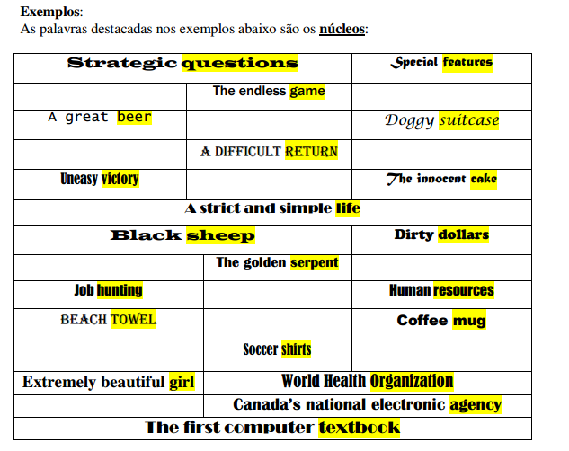

**INTRODUCTION TO COMPUTERS**

**1.1 History of Computers**

**1.1.1 Introduction**

A computer is a tool and partner in every sphere of human life and activity. Computers are bringing many changes in industry, government, education, medicine, scientific research, law, social service and even arts like music, movies and paintings. The areas of application of computers are confined only by the limitation on creativity and imagination.

What is a computer? A child might define a computer to be an instrument capable of producing a combined effect of radio, movie and television. This definition is close but still does not visualize the power and capabilities of a computer.

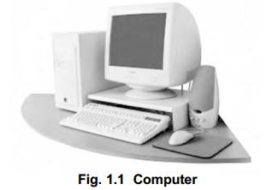

A computer is an electronic machine, capable of performing basic operations like addition, subtraction, multiplication, division, etc. The computer is also capable of storing information, which can be used later. It can process millions of instructions in a few seconds and at the same time with high accuracy. Hence a computer can be defined as an automatic electronic machine for performing calculations or controlling operations that are expressible in numerical or logical terms. Computers are very accurate and save time by performing the assigned task very fast. They don’t get bored.

Humans have always needed to perform arithmetic like counting and adding. During the pre-historic period, they counted either on their fingers or by scratching marks on the bones and then with the help of stone, pebble and beads. The early civilization had witnessed men develop number systems to keep track of the astronomical cycles, businesses, etc. The word ‘computing’ means an act of calculating’. After the invention of the manual calculating tools, the concept of using ‘electronic gadgets’ for computations were introduced which gave birth to the computers. The evolution of computers has passed through a number of stages before reaching

the present state of development. During the early development period, certain machines had been developed and a brief note of them is given below.

**1.1.2 Early History**

**2500 BC – The Abacus**

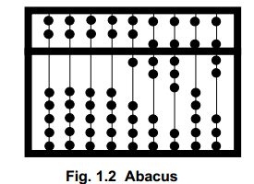

Abacus is the first known calculating machine used for counting. It is made of beads strung on cords and is used for simple arithmetic calculations. The cords correspond to positions of decimal digits. The beads represent digits. Numbers are represented by beads close to the crossbar. Abacus was mainly used for addition and subtraction and later for division and multiplication.

**1614 AD – Napier’s Bones**

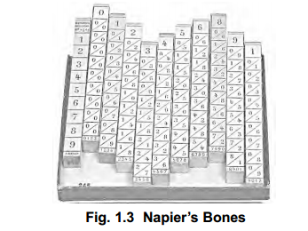

The Napier’s Bones was invented by John Napier, a Scottish mathematician as an aid to multiplication. A set of bones consisted of nine rods, one for each digit 1 through 9 and a constant rod for the digit ‘0’. A rod is similar to one column of a multiplication table.

**1633 AD – The Slide Rule**

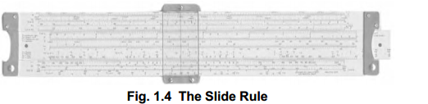

The Slide Rule was invented by William Oughtred. It is based on the principle that actual distance from the starting point of the rule is directly proportional to the logarithm of the numbers printed on the rule. The slide rule is embodied by the two sets of scales that are joined

together, with a marginal space between them. The suitable alliance of two scales enabled the slide rule to perform multiplication and division by a method of addition and subtraction.

**1642 AD – The Rotating Wheel Calculator**

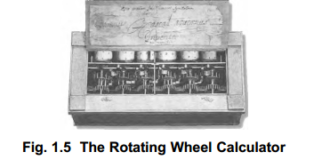

The Rotating Wheel Calculator was developed by a French philosopher, Blaise Pascal, using simple components such as gears and levers. This is a predecessor to today’s electronic calculator. He was inspired by the computation work of his father’s job and devised the model. He was only 19 years old, when he devised this model.

**1822 AD – The Difference Engine**

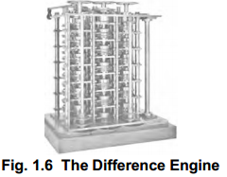

The Difference Engine was built by Charles Babbage, British mathematician and engineer which mechanically calculated mathematical tables. Babbage is called the father of today’s computer.

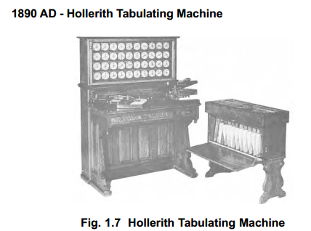

A tabulating machine using punched cards was designed by Herman Hollerith and was called as the Hollerith Tabulating Machine. This electronic machine is able to read the information on the punched cards and process it electronically.

**1.1.3 Generation of Computers**

The evolution of electronic computers over a period of time can be traced effectively by dividing this period into various generations. Each generation is characterized by a major technological development that fundamentally changed the way computers operated. These helped to develop smaller, cheaper, powerful, efficient and reliable devices. Now you could read about each generation and the developments that led to the current devices that we use today.

**First Generation - 1940-1956: Vacuum Tubes**

The first generation of computers used vacuum tubes for circuitry and magnetic drums for memory. They were large in size, occupied a lot of space and produced enormous heat. They were very expensive to operate and consumed large amount of electricity. Sometimes the heat generated caused the computer to malfunction. First generation computers operated only on machine language. Input was based on punched cards and paper tape, and output was displayed on printouts. First generation computers could solve only one problem at a time.

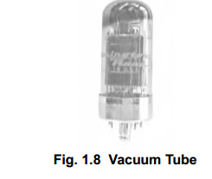

The Universal Automatic Computer (UNIVAC) and the Electronic Numerical Integrator And Calculator (ENIAC) are classic examples of first-generation computing devices.

**Second Generation - 1956-1963: Transistors**

The second generation of computers witnessed the vacuum tubes being replaced by transistors. The transistor was far superior to the vacuum tube, allowing computers to become smaller, faster, cheaper, energy-efficient and more reliable than their first-generation counter parts. The transistors also generated considerable heat that sometimes caused the computer to malfunction. But it was a vast improvement over the vacuum tube. Second-generation computers used punched cards for input and printouts for output.

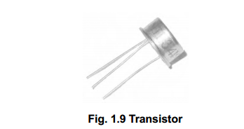

Second-generation computers moved from the use of machine language to assembly languages, which allowed programmers to specify instructions in words. High-level programming languages were also being developed at this time, such as early versions of COBOL and FORTRAN. The computers stored their instructions in their memory, which moved from a magnetic drum to magnetic core technology.

**Third Generation - 1964-1971 : Integrated Circuits**

The development of the integrated circuit left its mark in the third generation of computers. Transistors were made smaller in size and placed on silicon chips, which dramatically increased the speed and efficiency of computers.

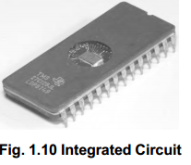

In this generation, keyboards and monitors were used instead of punched cards and printouts. The computers were interfaced with an operating system which allowed to solve many problems at a time.

**Fourth Generation - 1971-Present : Microprocessors**

The microprocessor brought forth the fourth generation of computers, as thousands of integrated circuits were built onto a single silicon chip.

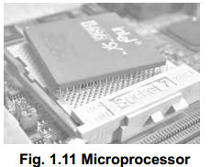

As these small computers became more powerful, they could be linked together to form networks, which eventually led to the development of the Internet.

**Fifth Generation - Present and Beyond: Artificial Intelligence**

Fifth generation computing devices, based on artificial intelligence, are still in their developmental stage. Fifth generation computers will come close to bridging the gap between computing and thinking.

**Activities**

A- Tomando por base as informações do texto responda:

a) O que é um computador ?

b) Qual a diferença entre a primeira e a terceira geração de computadores?

c) Descreva a diferença entre “Data” e “Information”.

d) O quê Herman Hollerith fez?

e) Para que servem os números no texto?

B- Retire do texto exemplos de Acróstico e descreva-os.

C- Retire dez grupos nominais, grife a palavra princiapal, e traduza-os.

D) Qual o tempo verbal predominante e sua relação com o significado do texto?